‘Gramejia’ Project Documentation Group 3



2602099794 - Christian Jonathan Gunawan

2602091955 - Nickson Tan Clarino

2602104592 - Muhammad Hafidz

* **Introduction**

In this century the internet has become a prominent thing in the economy section, business has found its way to the online world. Everything from house appliances and other necessities are available to be purchased from online services. With time passing by and technologies advancing through time, new and smaller devices are able to connect to the internet and make online purchases. As the internet has become a global phenomenon and online purchasing has become much easier especially mobile devices where people can carry them everywhere seamlessly. Among many businesses that have found their way to the Internet, book stores have also found their way to the online store or e-commerce. Gramejia is one example for online stores or e-commerce.

Gramejia is an online book store, where you can buy a book while also being able to manage your own store . As a user, you can view a list of books and view the details of the user's chosen book and also purchase the book. Users are able to add balance in their account. Users can view the history of the recent purchase. Users can manage their shopping cart of the chosen books. As an admin also has the capabilities of managing their store including adding new books, viewing book detail, updating books and deleting books.

* **Login Page**

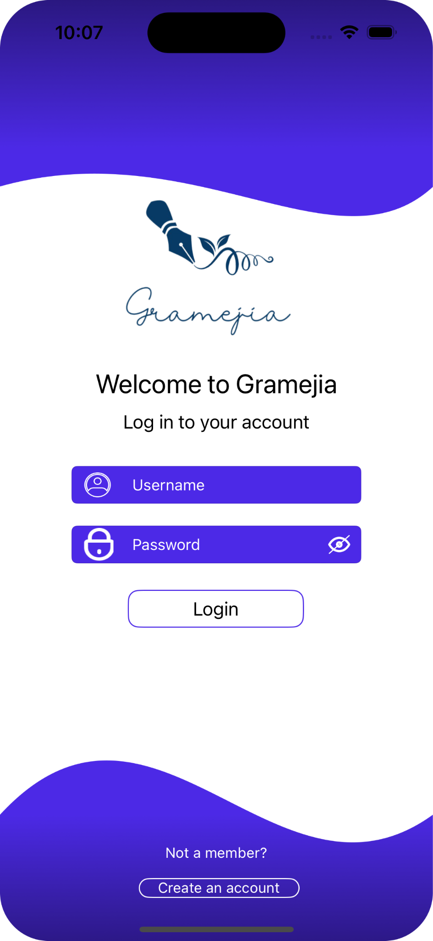

* + On this page, the user can sign in to Gramejia by filling the username and password field
    - The user must fill in all the username and password fields. If the one or both the textfield are empty then it will show an alert “Please insert all field”
    - If the user has insert the username but the username does not exist in core data then it will show an alert “Username doesn’t exist, create account”
    - If the user has insert the password but the password does not exist in core data then it will show an alert “Your password doesn’t exist in our system”
    - If user clicked the eye icon in password field, it will reveal the password created by user and if user clicked the eye icon again, it will return to its default form
    - If the user does not have an account, they can click “Create an account” button then it will redirect user to Register Page
  + If the user has successfully login then user will be redirected to Home Page
* **Register Page**

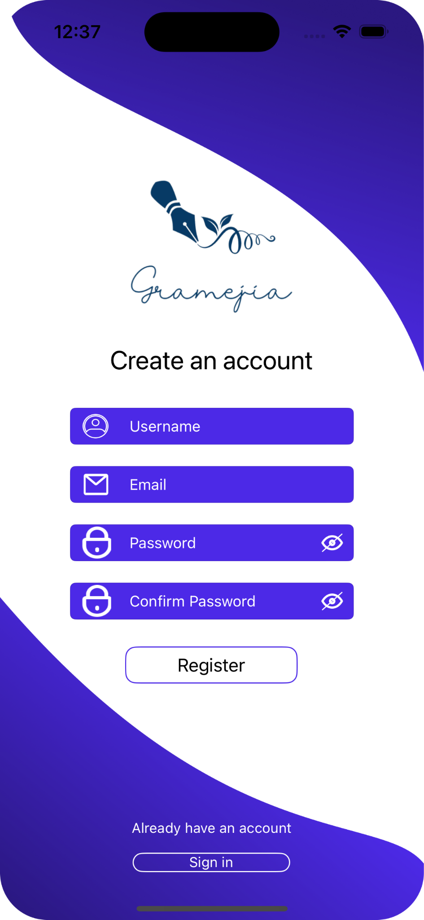

* + On this page user can input their data information to create an account, The required information are
    - Username
    - Email
    - Password
    - Confirm Password
  + If there is some missing data, it will trigger an alert where the required data must be filled. The possible error are :
    - If the user does not fill all of the required textfield then it will show an alert “Please insert all field” with the message “Every field must be filled in”
    - If the password does not match with the confirm password then it will show an alert “Password and Confirm Password doesn’t match”
  + If user clicked the eye icon in password and confirm password field, it will reveal the password and confirm password created by user and if user clicked the eye icon again, it will return to its default form
  + If all of the required data are filled in and when the user click the Register button then it will show an alert “Successfully create an account” with the message “Thank you for creating an account”
  + If the user already has an account, they can click the Sign in button to redirect them to the Login Page
* **Home Page**

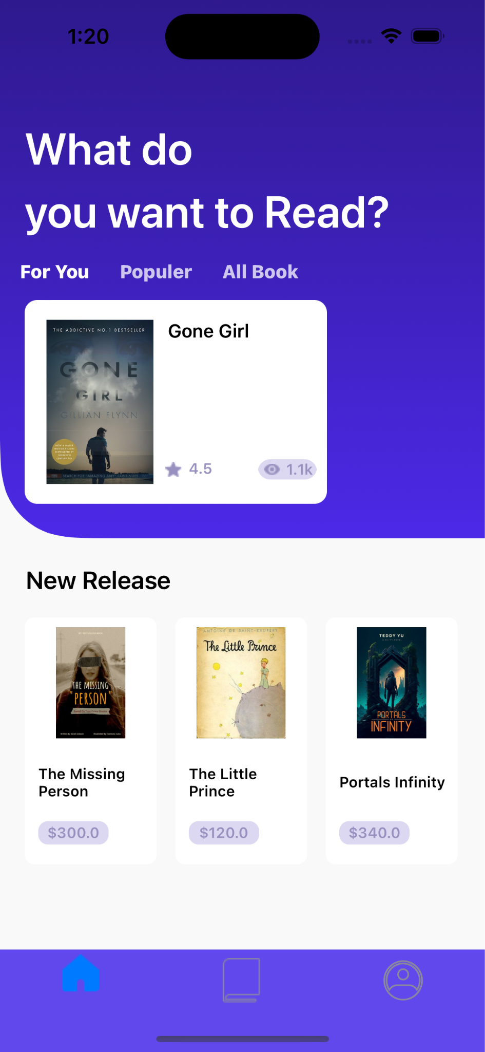

* + After successfully login, the user will enter the HomePage where user will be shown a collection view of the book fetch from the core data
  + User can tap or click one of the book and it will redirect user to the Book Detail Page
* **Book List Page**

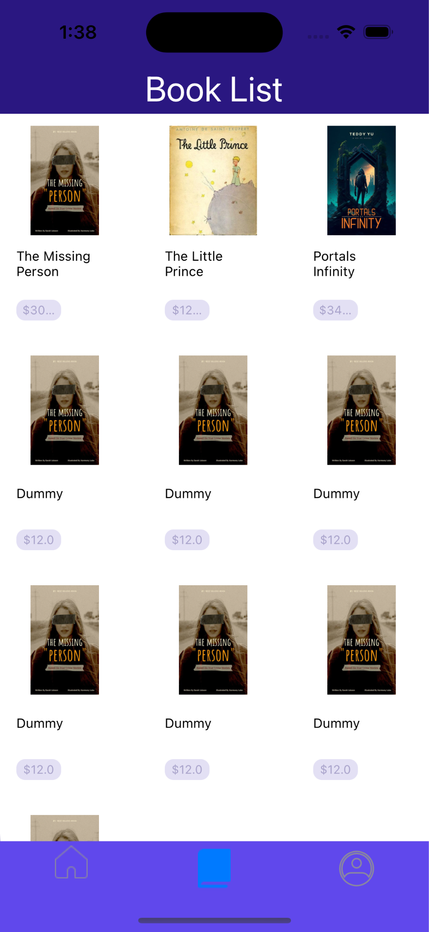

* + On this page user will be shown a complete list of Book fetched from the core data and created by the admin
  + User can tap or click one of the book and it will redirect user to the Book Detail Page
* **Book Detail Page**



* + The Book Detail Page show a complete detail of a book chosen by user in the Home Page and Book List Page
  + User can purchase the book by clicking the “Buy Book for (book price)”, the book will be sent to Cart Page where user can customize the quantity and check out for payment.
    - If user click the button then it will show an alert “This book successfully added to cart” with 2 option of action
      * If user click “No” action button, user will redirected to Book List Page or Home Page depends on which page where the user click the book
      * If user click “Go” action button, user will be redirected to Cart Page
* **Profile Page**

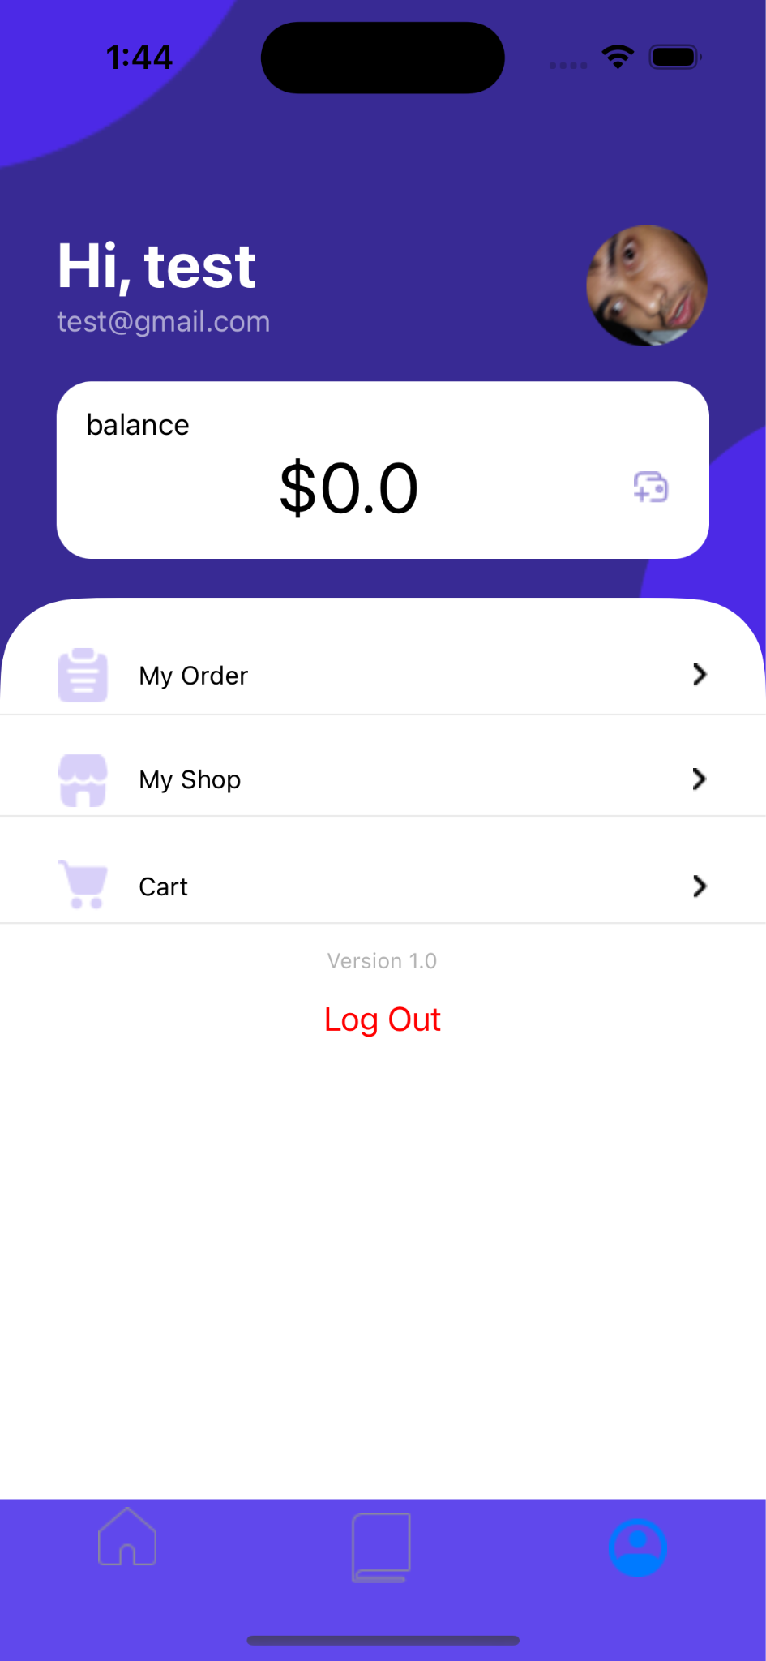

* + Profile page show the personal information of the user including name, email and balance
  + Balance are owned by user in order to buy a book in the store, user could add balance by click the wallet button

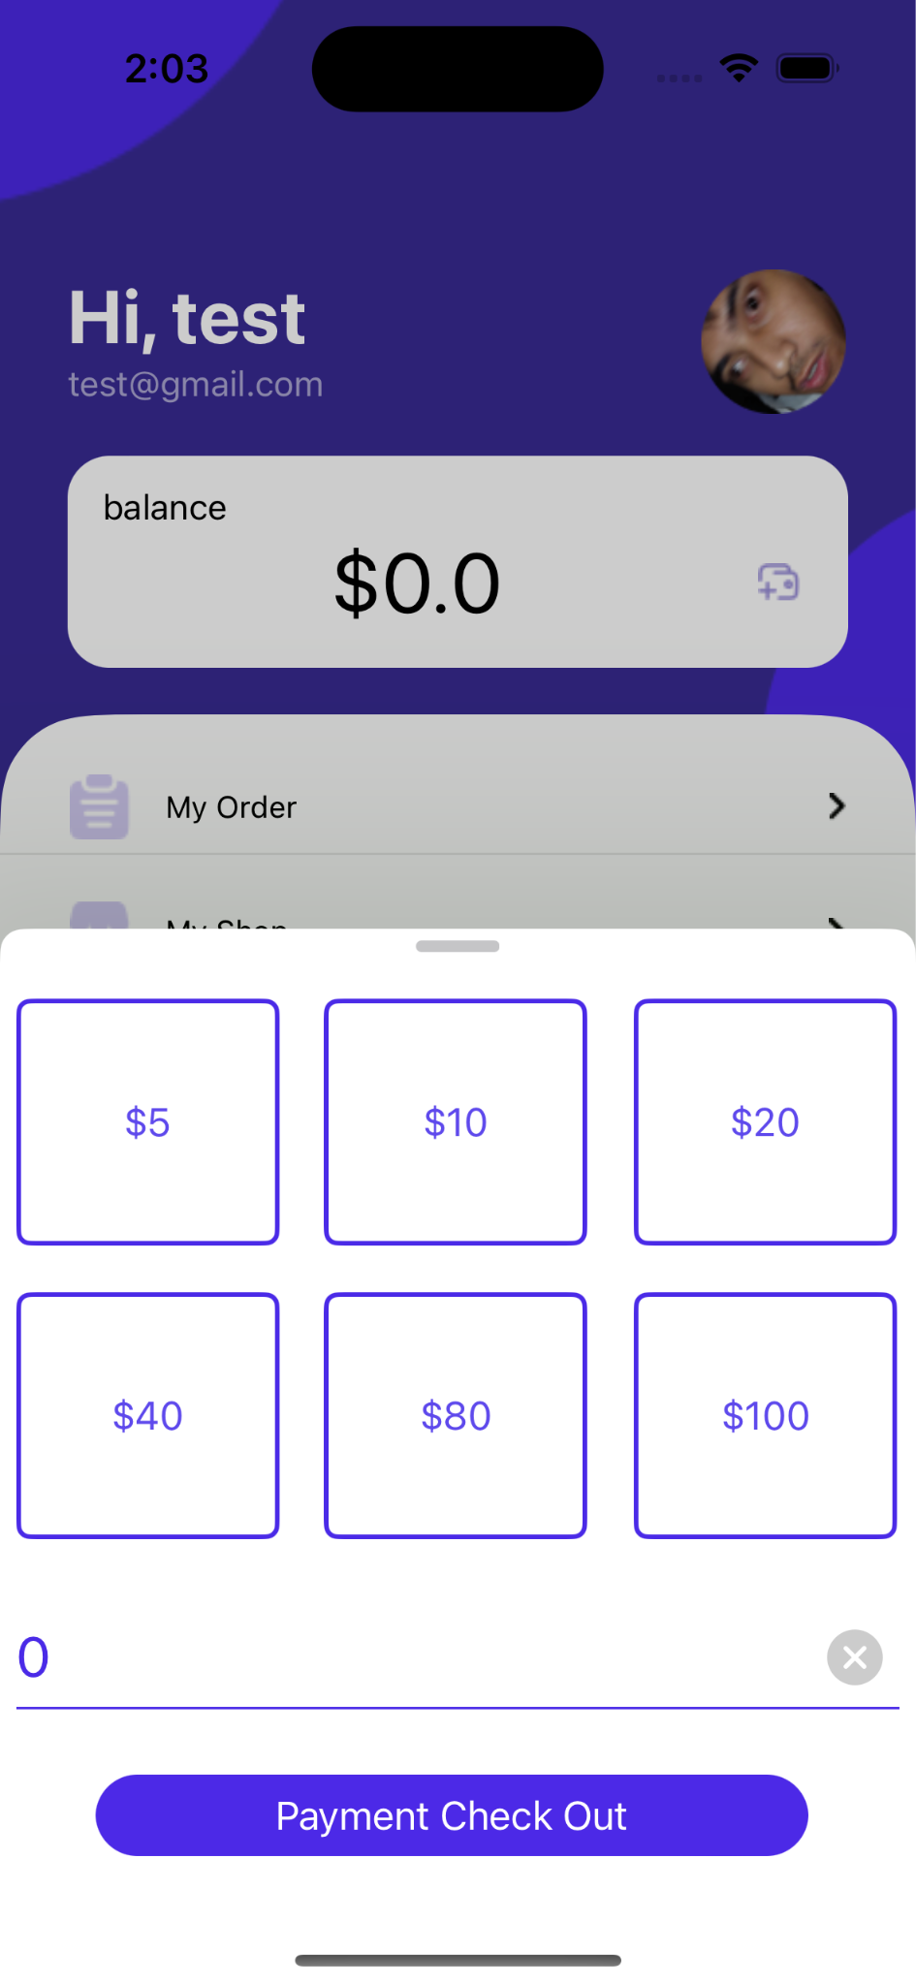

* + If the user click the wallet button, then a pop up will appear
    - There are six button of balance choice in which are “$5, $10, $20, $40, $80, $100”
      * User could tap or click the button in which would add the nominal based on the button, and user are able to click the button multiple time and it would add more to the nominal
    - If user does not want to use the balance choice, then user are able to add custom balance by click the textfield where the “Nominal” placeholder are existed
    - User can add the balance by clicking the “Payment Check Out” button then it will show a custom popup
      * If user insert 0 then it will show an alert “Please insert the nominal”
        + The nominal must be more than 0
      * If the user has inserted more than 0 and clicks the “Payment Check Out” button, then it will redirect the user to the Payment Top Up Page.
        + This page shows the confirmation of top up and it shows the name and the total nominal of the top up.

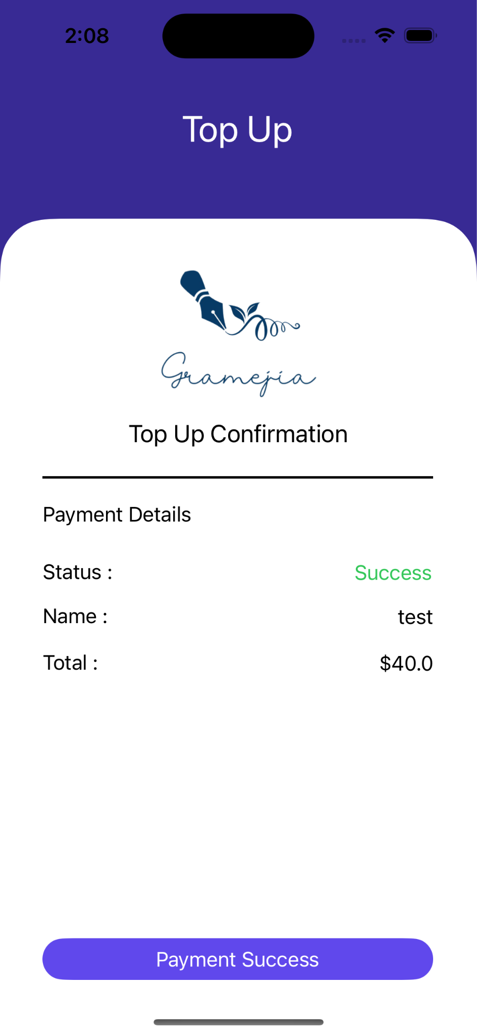

* + - * If the user clicks the “Payment Success” button, then it will redirect the user back to Profile Page and the balance in the Profile Page will increase based on the total nominal of top up.

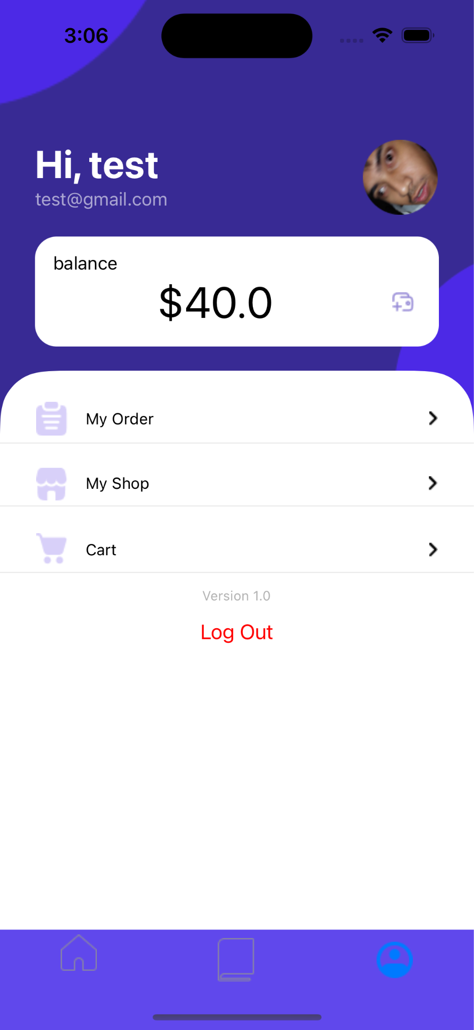

* + If user click the “My Order” button then it will redirect user to History Page
  + If user click the “My Shop” button then it will redirect user to Admin Page
  + If user click the “Cart” button then it will redirect user to Cart Page
  + There is a logout button for the user to exit the application. When pressing the logout button, the user will be redirected to the Login Page.
* **My Order (History) Page**

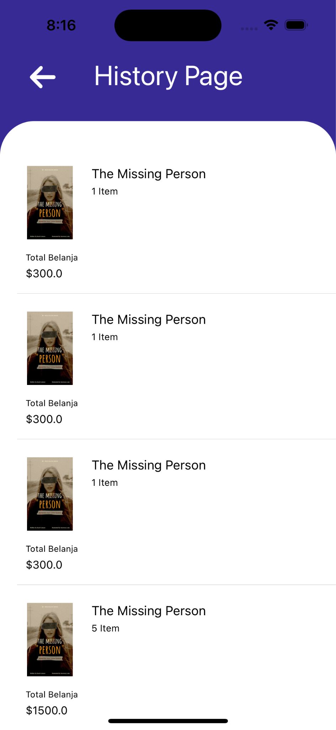

* + This page contains a list of completed transactions made by the user.
  + After user clicked “Check Out” from Cart Page, the book will be sent to My Order (History) Page
  + If the user clicked one of the chosen books in the list then it will redirect the user to the Book Detail Page, which allows the user to repurchase the same book that has been purchased by the user.
* **Cart Page Page**

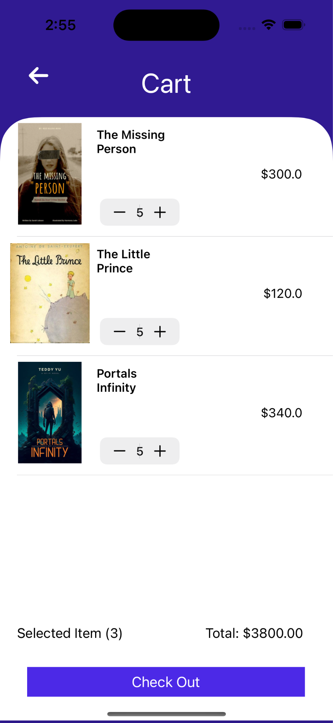

* + After user click the buy button, the selected book will be moved to Cart Page where user can edit the quantity of the selected book for purchase
    - User are able to increase and decrease the number of quantity for purchase
      * If user increase or decrease the quantity, then the total price for purchase will also increase and decrease based on the book price
    - User are able to delete book on the Cart Page by swipe the cell to the left

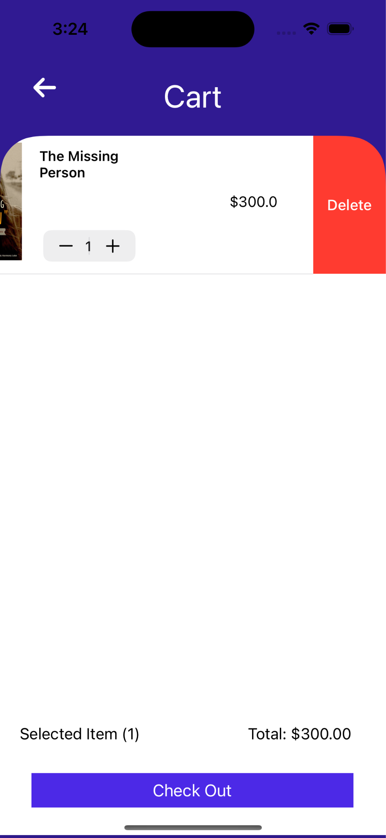

* + - * If user delete the book on the cart, then the Selected Item will also decrease
  + If user click “Check Out” button
    - If user balances are enough or more than enough to pay the total of price then the balance in Profile Page will be deducted based on the price on Cart Page and it will show a custom alert “Success” and it will redirect user back to its previous page and the book will be sent to My Order (History) Page and the list in Cart Page will be deleted.

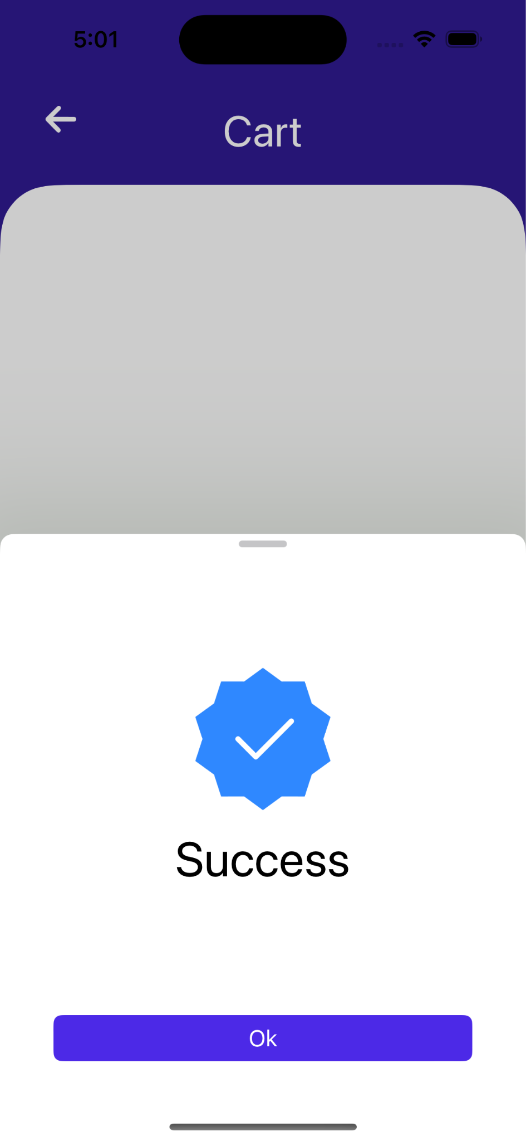

* + - If user balances are not enough then it will show a custom alert “Insufficient balance!”

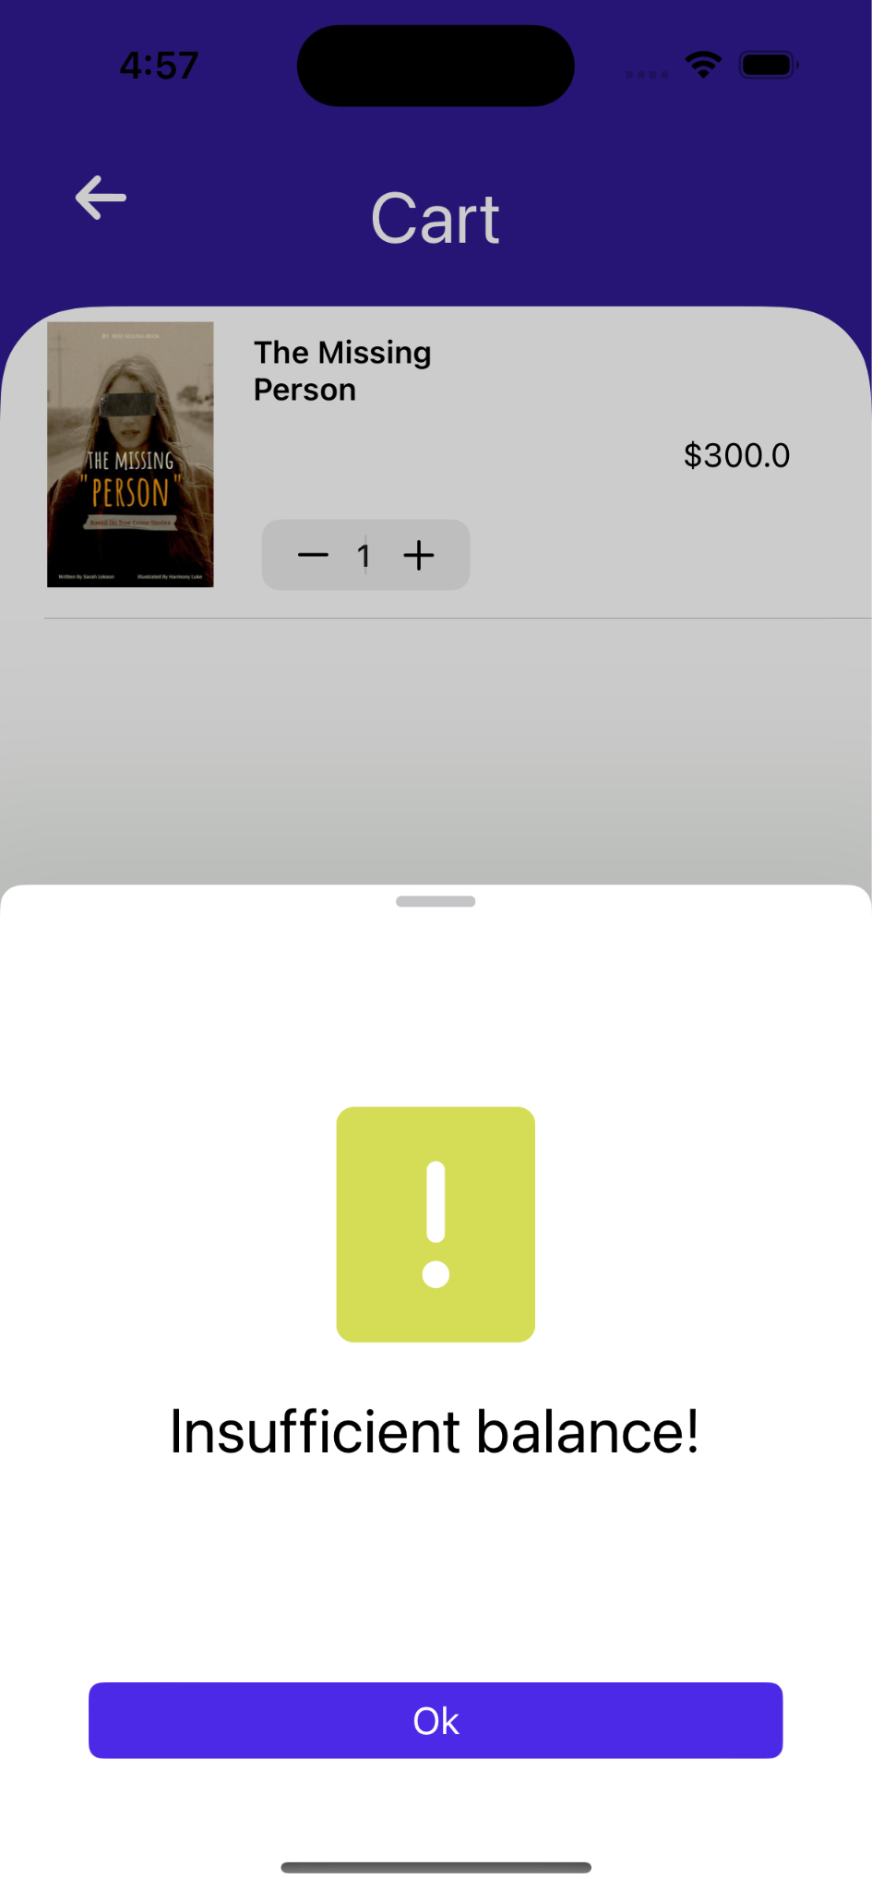

* **My Shop Page**

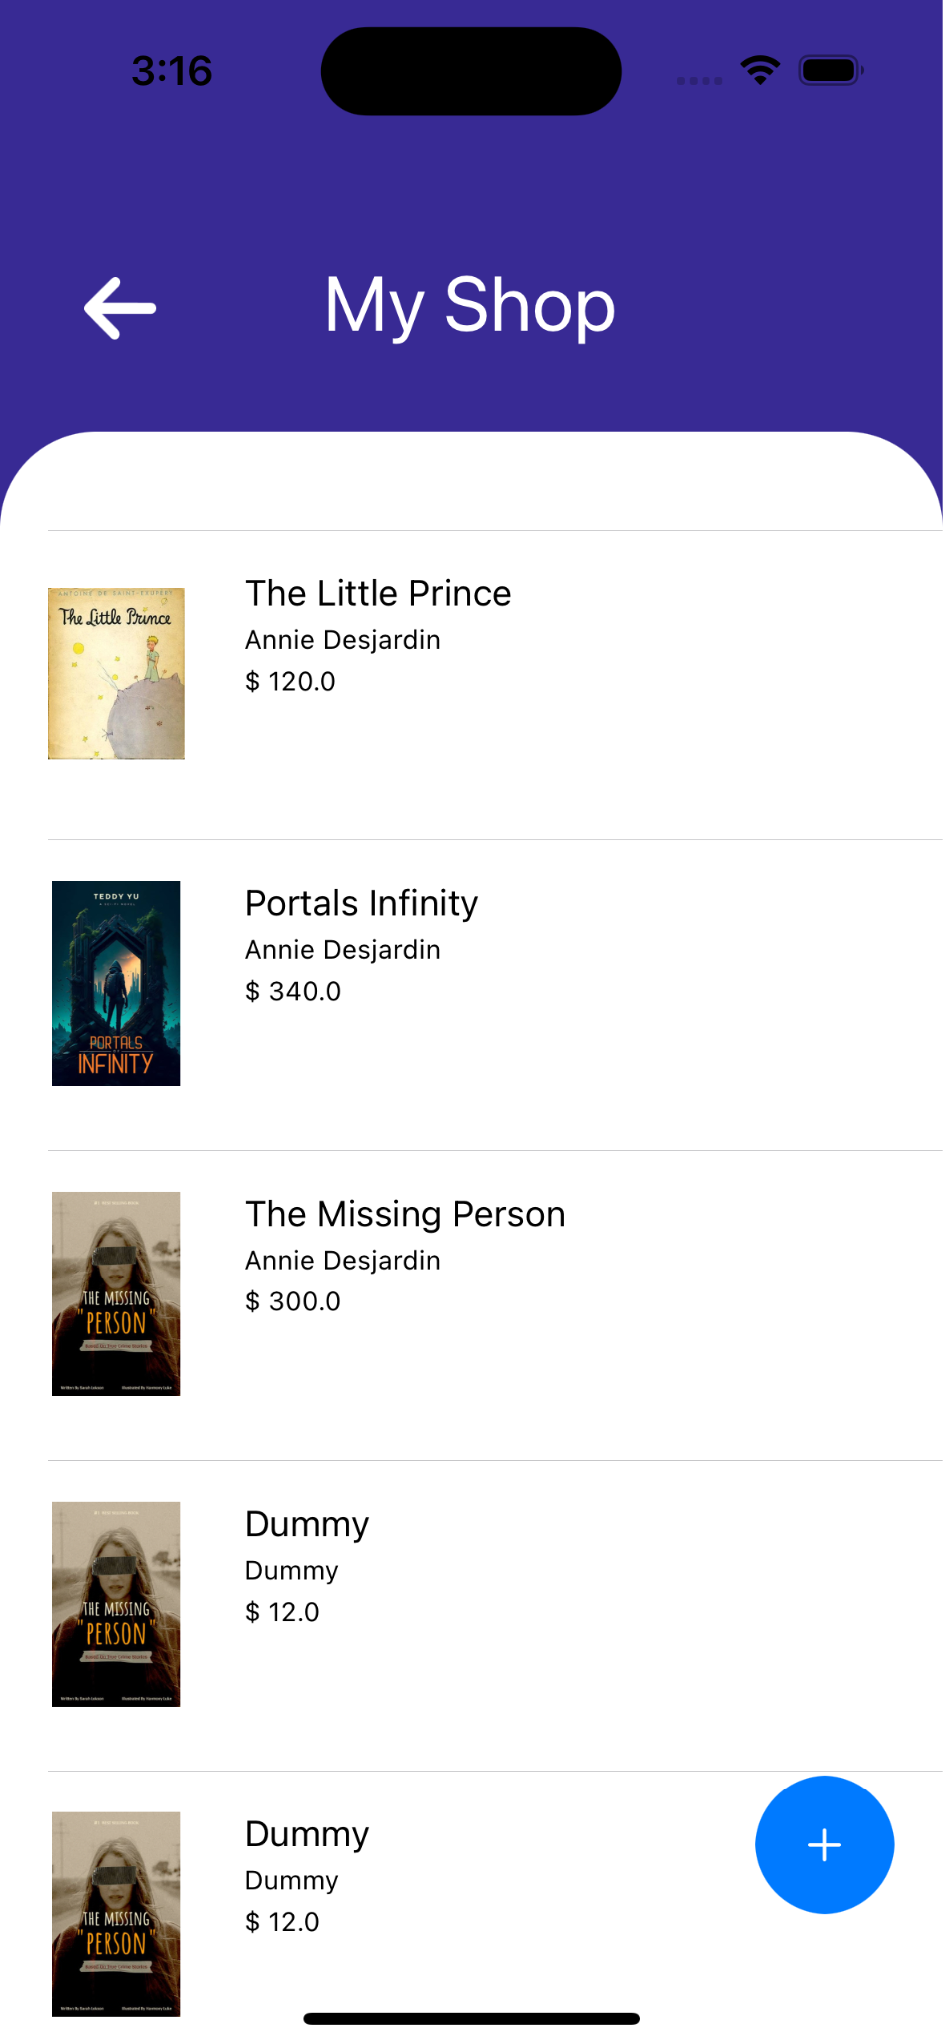

* + This page is an admin page where they can view the list of books that they sell and with the capabilities of view book detail, update book detail, add new book and delete book.
    - If admin clicks one of the books then it will redirect admin to Book Detail Admin Page.
    - Admin are able to delete the book by swiping the cell to the left.

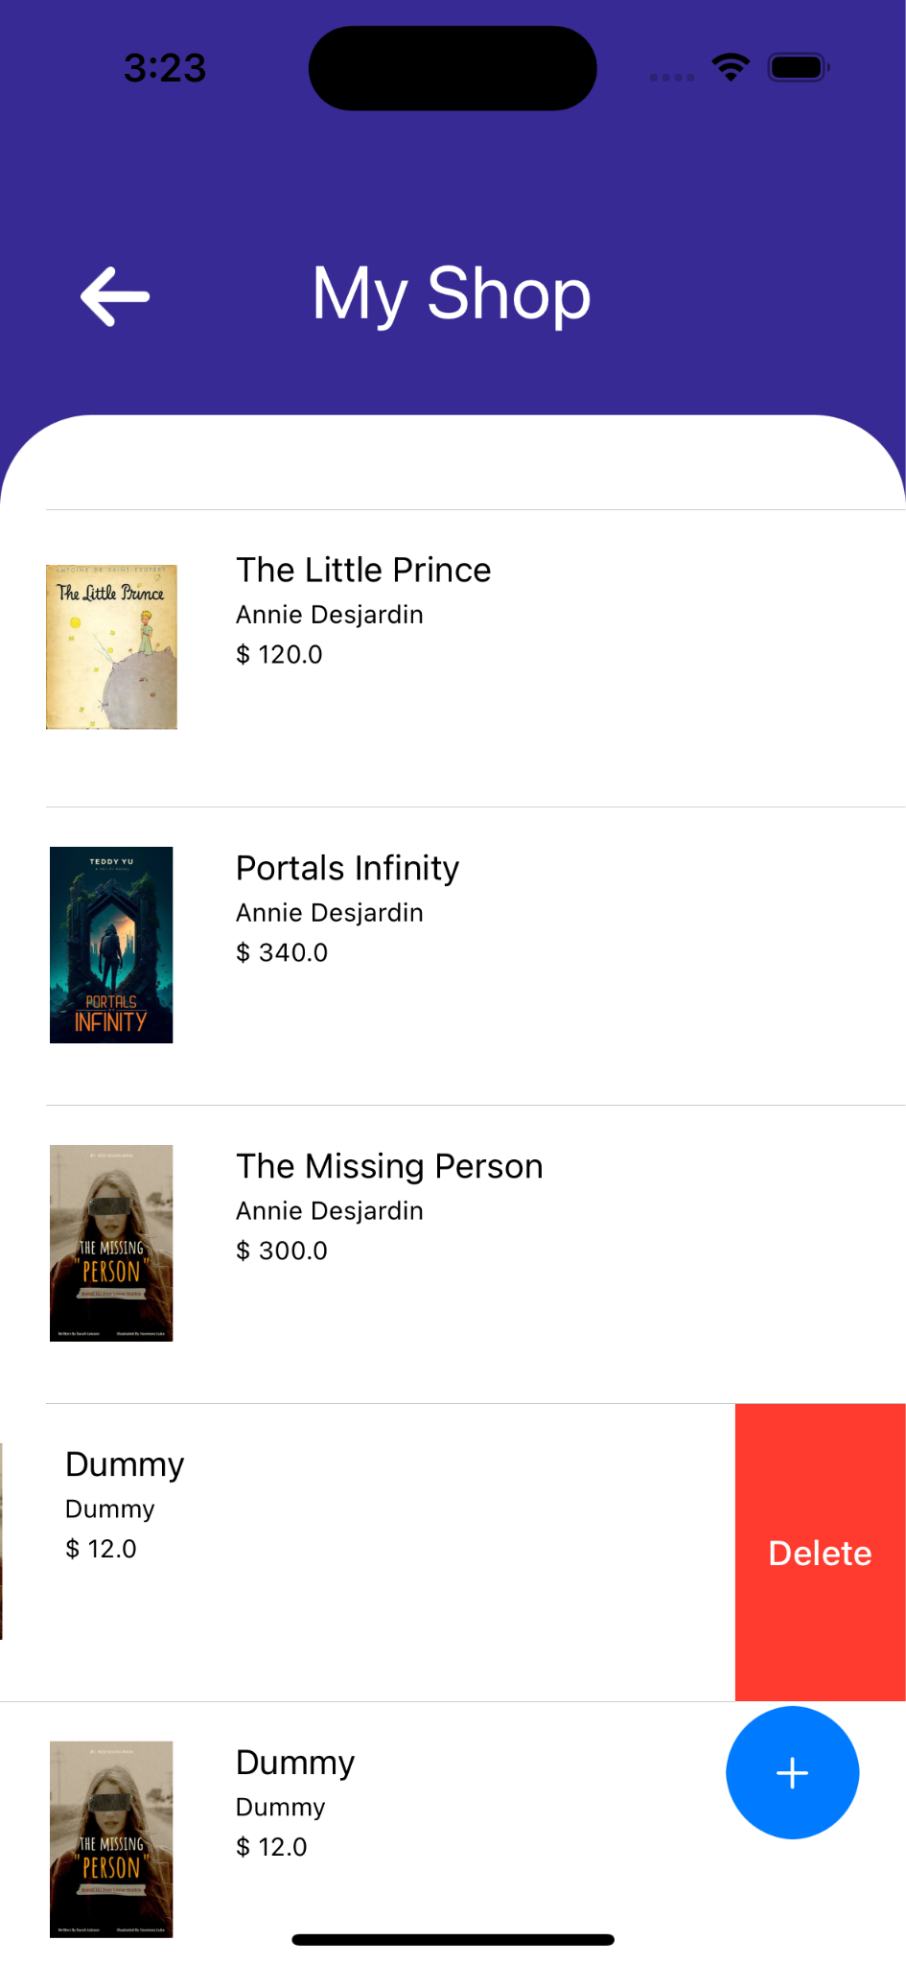

* + - If admin click the “+” floating button then it will redirect admin to Add New Book Page
* **Add New Book Page**

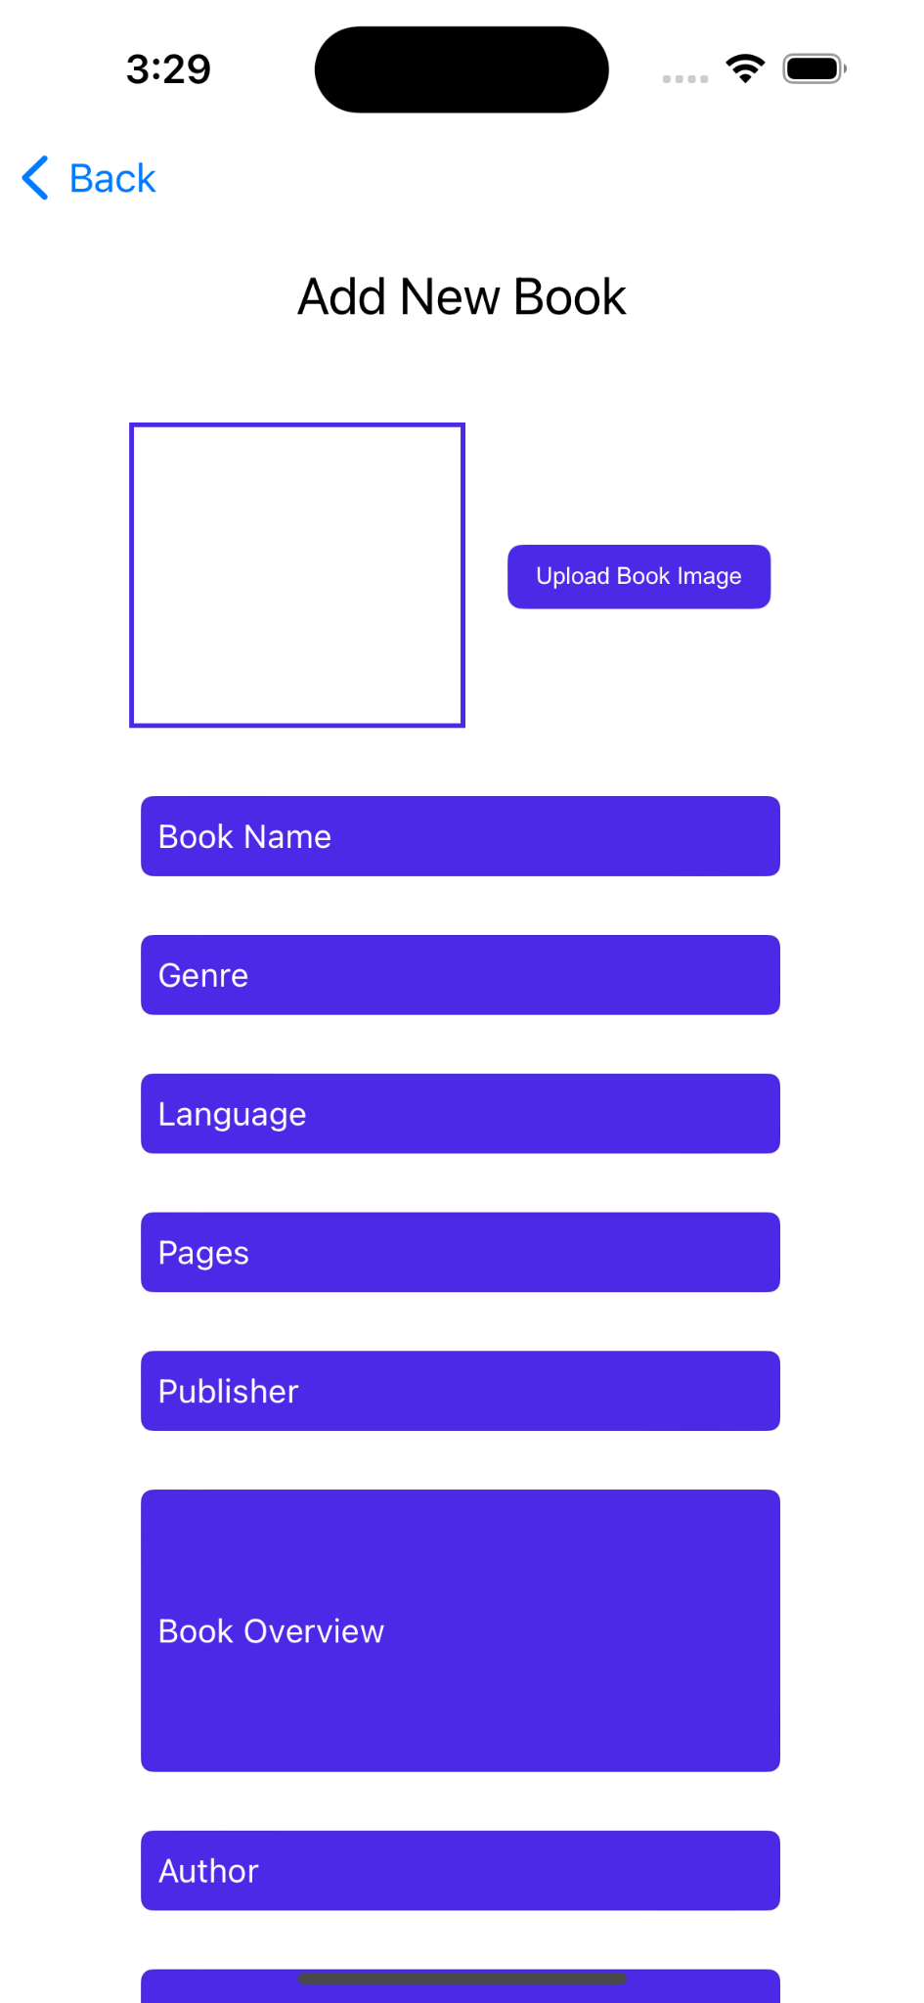 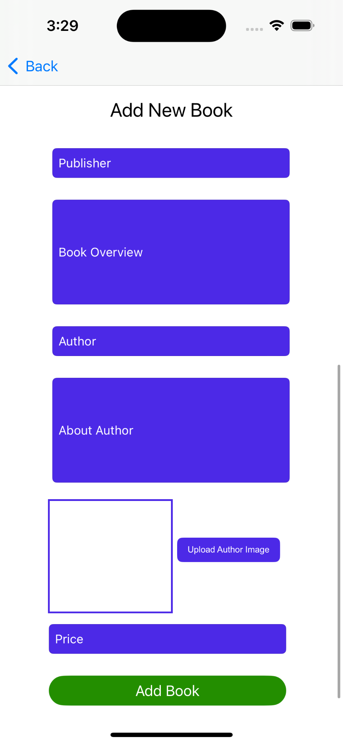

* + This is the page where admin create a new book
  + All of the textfield must be filled
    - If book name is empty then it will show an alert “Name is required”
    - If book genre is empty then it will show an alert “Genre is required”
    - If book language is empty then it will show an alert “Language is required”
    - If book pages is empty then it will show an alert “Page must be valid number greater than 0”
    - If book publisher is empty then it will show an alert “Publisher is required”
    - If book overview is empty then it will show an alert “Overview is required”
    - If book author is empty then it will show an alert “Author is required”
    - If about book is empty then it will show an alert “About author is required”
    - If book price is empty then it will show an alert “Price must be a valid number greater than 0”
    - If book image is empty then it will show an alert “Please select a valid image for the book”
    - If author image is empty then it will show an alert “Please select a valid image for the author”
  + If all the textfield has been filled then it will show an alert with the title “Successfully added” and the message “Data successfully added”
    - If user click “Ok” action button, user will be redirected to its previous page
* **Book Detail Admin Page**



* + This a complete book detail page for admin, admin are able to view the complete detail of the book chosen by admin in My Shop Page
  + If admin click “Edit Book” then it will redirect admin to update book page
* **Update Book Page**

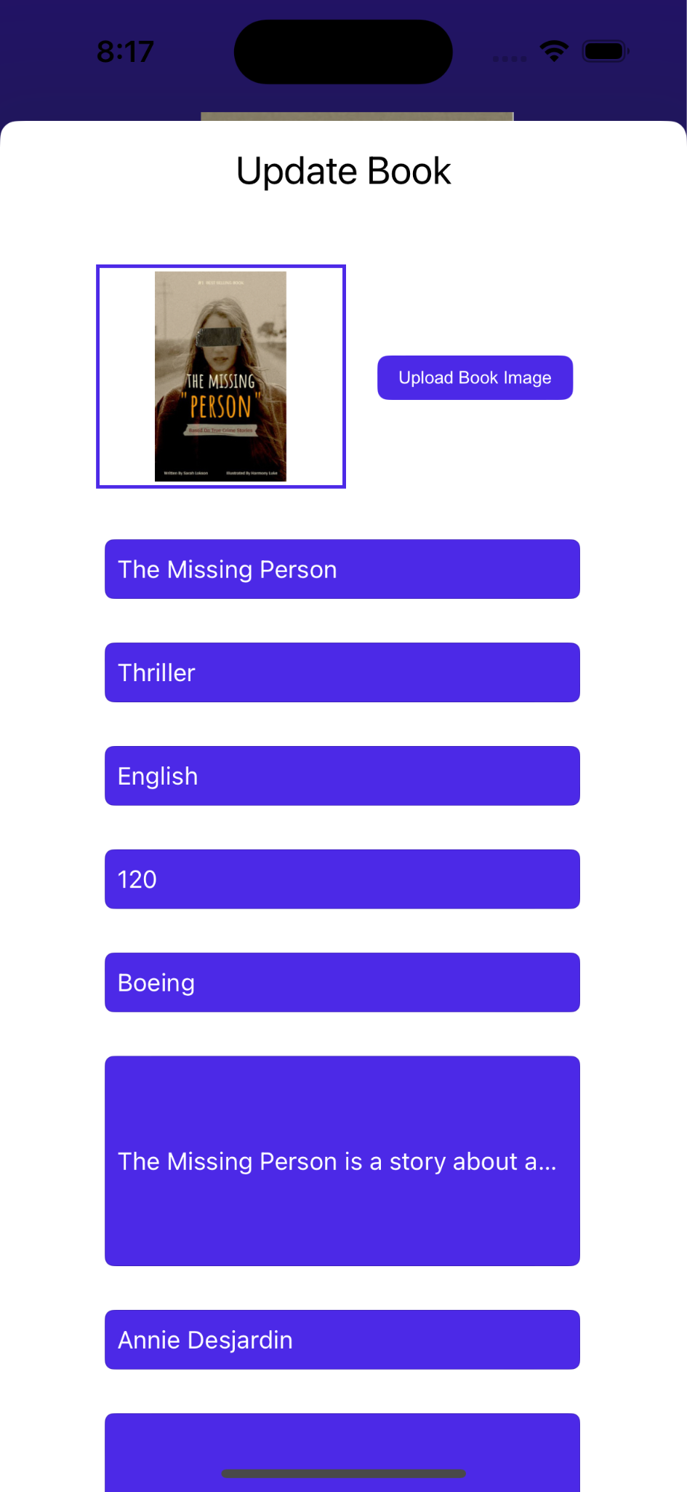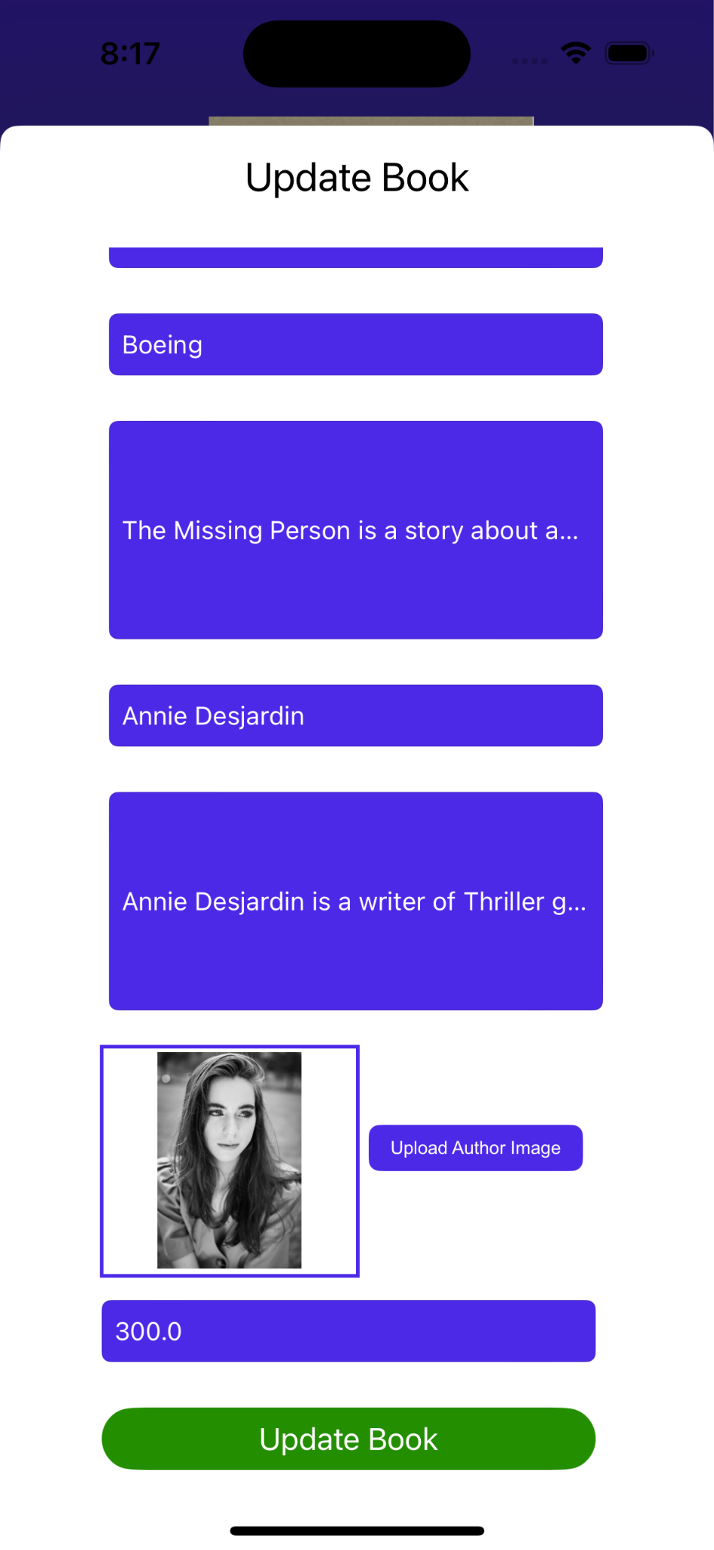

* + This page allow admin to update the detail of the book chosen by the admin
    - If book name is empty then it will show an alert “Name must not empty”
    - If book genre is empty then it will show an alert “Genre must not empty”
    - If book language is empty then it will show an alert “Language must not empty”
    - If book page is empty or less than 0 then it will show an alert “Page must be greater than 0”
    - If book publisher is empty then it will show an alert “Publisher must not empty”
    - If book overview is empty then it will show an alert “Overview must not empty”
    - If book author is empty then it will show an alert “Author must not empty”
    - If about book author is empty then it will show an alert “About author must not empty”
    - If book price is empty or less than 0 then it will show an alert “Price must be greater than 0”
    - If book image is empty then it will show an alert “Book image must not empty”
    - If author image is empty then it will show an alert “Author image must not empty”
  + If the admin clicks the “Update Book” button and all of the required data has met the requirement then it will show an alert with title “Successfully Updated” and message “Data successfully updated” and will redirect admin back to Book Detail Admin Page.
* **Referensi**
  + [Figma Reference Page](https://www.figma.com/design/S9XwmSQ61MeoHQCBitfMQx/Project-MMS?node-id=0-1&t=21HmaJG3BIZ0xpes-1)